Smart Home

Software Design Document

Version 0.1

Document update history:
Date | Author | Description
08,12,2018 | Jukka Lindberg | Decribes happy use cases to build up and control one function, though figures include other sub use cases too.

Description
This document describes the software design of Home Automation application. First chapter illustrates all use cases and describes case by case what happens between user and the system. Second chapter drills down to message interactions between user and the main components for each individual use case. Third chapter concentrates on system's class model and finally, some ideas about additional features are listed for possible future development.

Use cases
Main level use cases are categorized in 4 groups as shown in Fig.1: user authentication, managing home and its room’s, managing devices and their functions each room can have and finally control ling individual function of device.
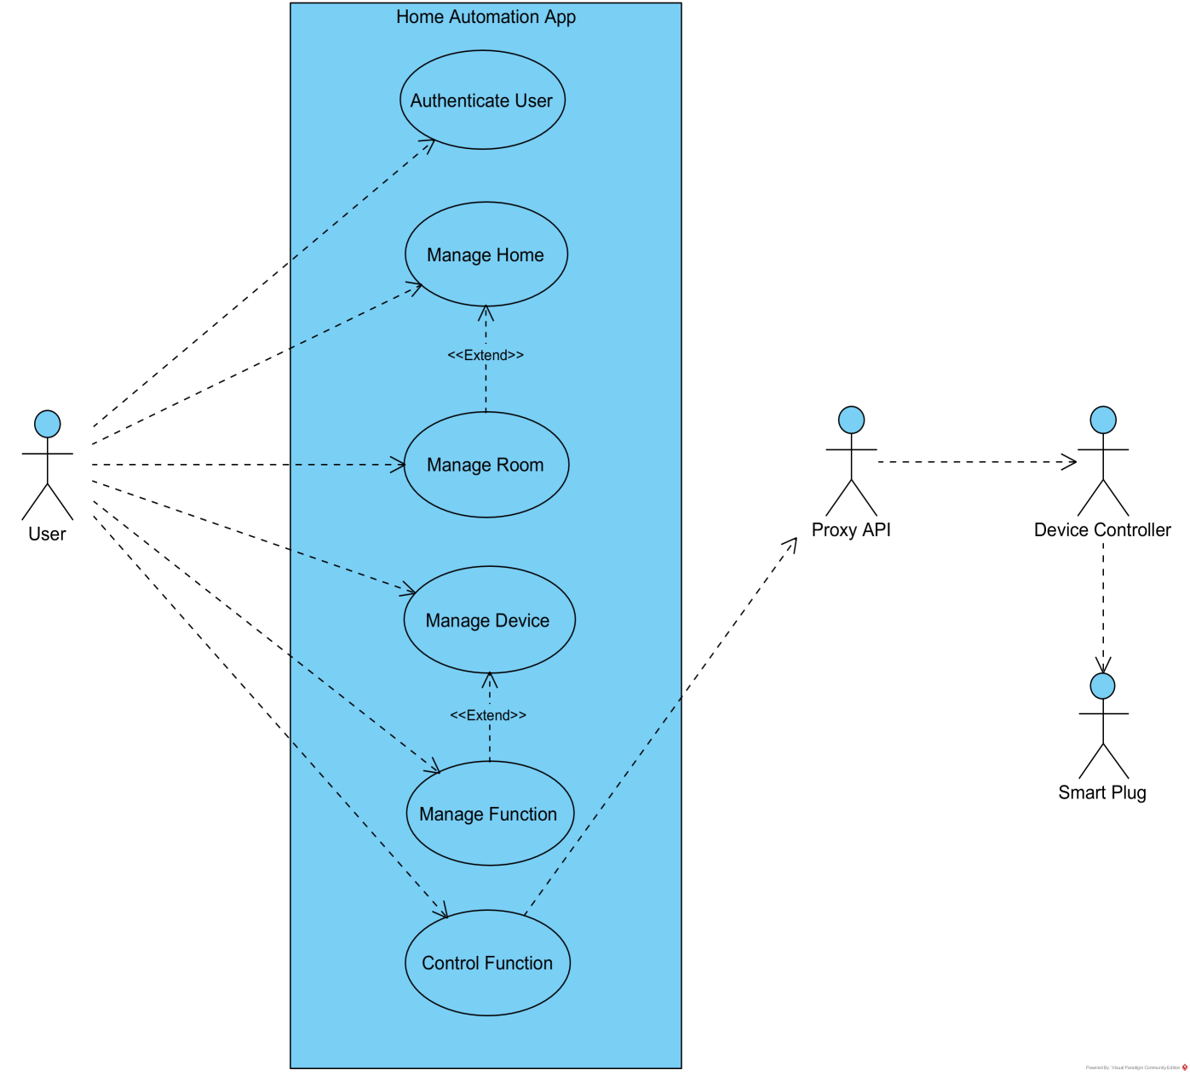
Fig.1 Main level use cases

Authenticate User
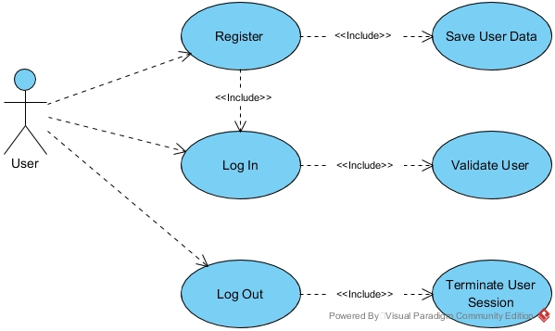
Use case is divided in three different sub use cases: register, log in and log out user as shown Fig. 2;
Fig.2 Authenticate User sub use cases

Register
Register
Pre-conditions: User has not registered into system.
User | System
Navigates to application URL.  User press register link.  Enters full name, user name and password and press 'Register' button. | Opens login log in form with text like “If not registered yet, please register here”.  Opens register form.  Checks parameters. If parameters OK, saves user data with salted password into database. Finally logs user in and closes register form.
Post conditions: User sees landing page with user’s full name and text link to create home.

Login
Login
Pre-conditions: User has registered and home with one or more rooms exists in system.
User | System
Navigates to application URL.  Enters user name and password and press 'Log in' button. | Opens log in form with text like “If not registered yet, please register here”.  Checks user name and password and assures user has already registered. If OK, logs user in, creates new user session and closes login form.
Post conditions: User sees one or more closed room sections with title bar inside home section.

Logout
Logout
Pre-conditions: User has logged in.
User | System
Press ‘Logout’ | Removes user’s session and redirects to login form
Post conditions: User sees login form with text like “If not registered yet, please register here”.

Manage Home
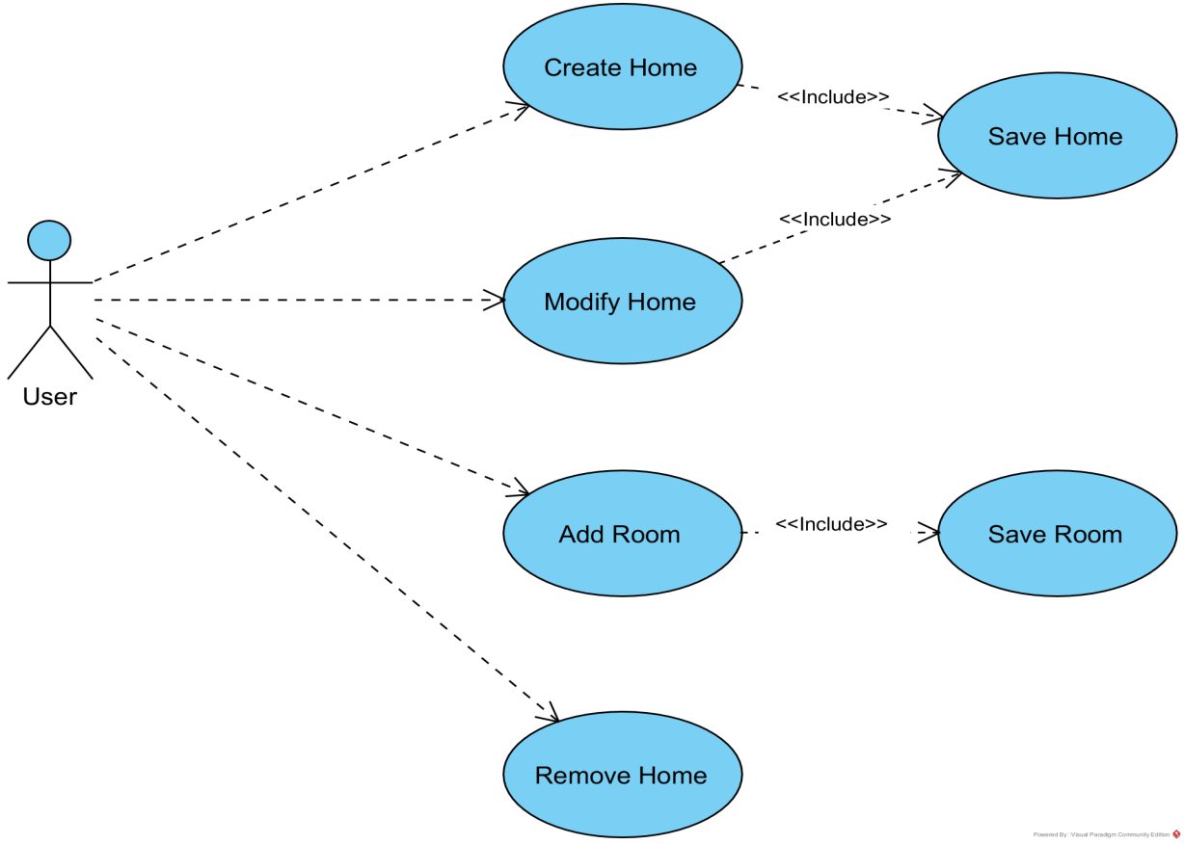
Use case has four sub level use cases: Create Home, Modify Home, Add Room and Remove Home to build up/modify Smart Home environment where the controlled devices will be located.
Fig.3 Manage Home sub use cases

Create Home

Create Home
Pre-conditions: User has logged in and home does not exist in system.
User | System
Press ‘create home’ link in landing page.  Enters home name, service address and port and press 'Create' button. | Opens home dialog form.  Checks parameters. If parameters OK, saves new home into database and closes dialog form.
Pre-conditions: User sees new home section with name on its title bar.

Add Room

Add Room
Pre-conditions: User has logged in and home exists in system.
User | System
Press add room icon on title bar of home section.  Enters room name and selects room type (e.g. ‘living room’) from dropdown list and press 'Add' button. | Opens room dialog form.  Checks parameters. If parameters OK, saves new room into database and closes dialog form.
Post conditions: User sees new closed room section with name on its title bar inside home section.

Manage Room
Use case extends Manage Home use case by providing four sub use cases as shown in Fig. 4: Modify Room, Remove Room, Add Device and Open Room View.
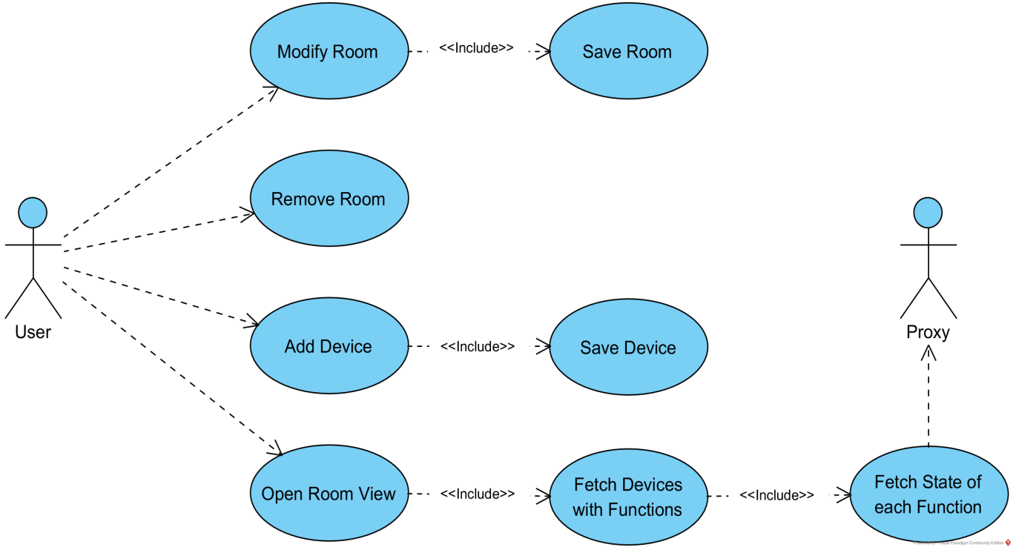
Fig.4 Manage Room sub use cases

Add Device
Add Device
Pre-conditions: User has logged in and home with at least one room exists.
User | System
Press ‘add device’ icon on title bar of room section.  Enters device name and selects device type (e.g. ‘Smart Plugin’) from dropdown list and press 'Add' button. | Opens device dialog form.  Checks parameters. If parameters OK, saves new room into database and closes dialog form.
Post conditions: User sees new device box with name on its title bar inside room section.

Open Room View
Open Room View
Pre-conditions: User has logged in and room with one or more devices exists for home.
User | System
Press open (‘v’) icon on title bar of room section. | Retrieve one or more devices for room from database.  Opens room section view that includes one or more device boxes.
Post conditions: User sees one or more device boxes with name on its/their title bar inside room section.

Manage Device
Use case has three sub level use cases: Modify Device, Remove Device and Add Function to manage individual devices located in rooms.
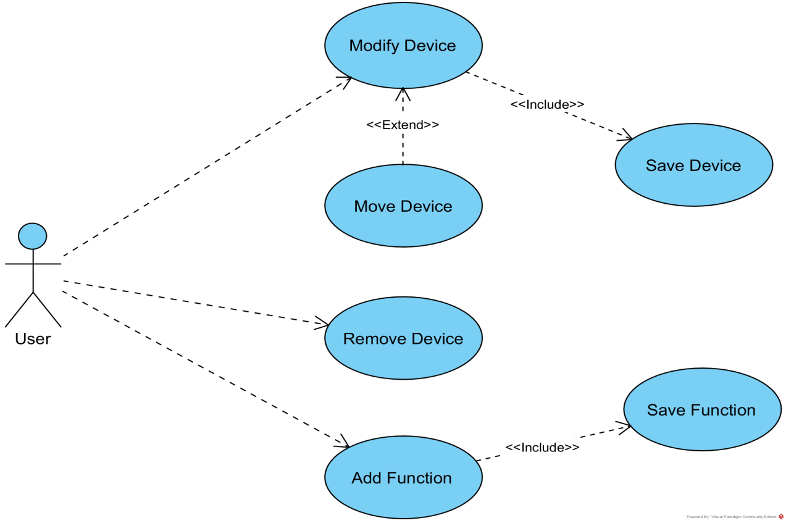
Fig.4 Manage Devices sub use cases

Add Function
Add Function
Pre-conditions: User has logged in and room with one or more devices exists for home.
User | System
Press ‘add function’ icon on title bar of device box.  Enters function id and name, selects function type (e.g. on/off switch) from dropdown list and press 'Add' button. | Opens function dialog form.  Checks parameters. If parameters OK, saves new function into database and closes dialog form.
Post conditions: User sees new function icon (e.g. on/off switch) inside device box.

Control Function
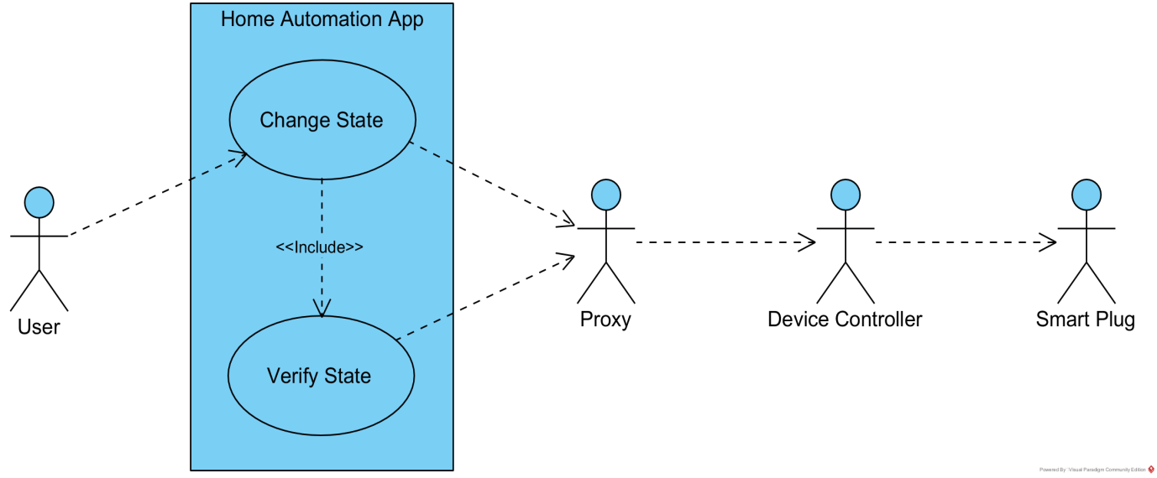
This use case consists one sub use case as shown in Fig. 5: Change State to set new state of a function in particular device which includes Verify State use case to make sure that the function’s state really equals the state of physical device.
Fig 5: Control Function use cases

Change State
Change State
Pre-conditions: User has logged in and function with one or more devices exists in room of home.
User | System
Press ‘function’ icon in device box. | Checks that function with given id were found in database and sends 'change function state' request to proxy.  Verifies previously changed state from proxy and updates ‘function’ icon to match new state.
Post conditions: User sees changed function state (e.g. switch turned on) inside device box.

